DECEMBER 2012

VIRGIN LONDON MARATHON
VOLUNTEERS MONTHLY

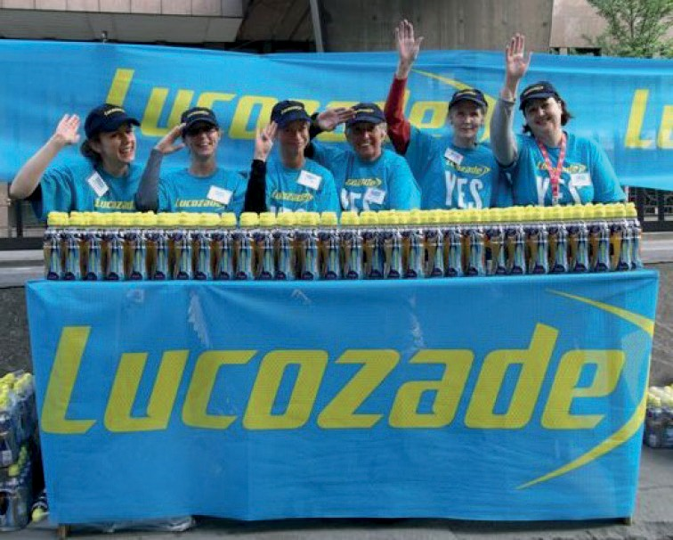WELCOME TO THE NEW VOLUNTEER NEWSLETTER!

As the volunteering programme grows as the events calendar expands we thought it would be a good idea to start a monthly newsletter to keep you up to date with the goings on at the LM HQ. As of this week I have taken over
the role as Volunteer Coordinator so I will be writing the newsletter and would love to hear from you & your teams to what you are all up to outside Marathon seasons. If you have a story you would like to be featured in the newsletter please email
clairel@london-marathon.co.uk Equally if there is anything you would like to hear from the Operations Team in the newsletter drop me a line.

I look forward to working with you in the New Year.

Claire

LONDON MARATHON CHRISTMAS HANDICAP!

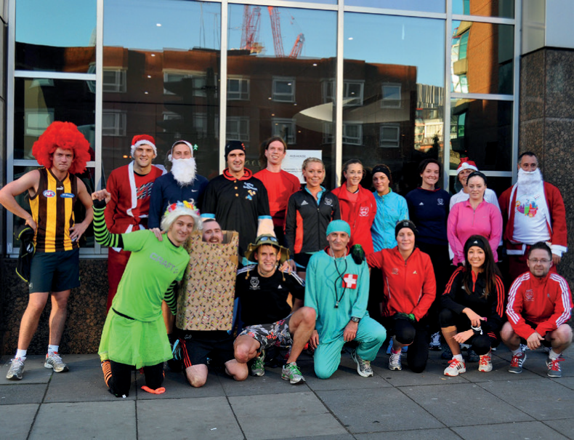In case you didn’t believe that the London Marathon HQ team are an active bunch - here (most) of them are after the Christmas Handicap fancy dress race along Embankment. Some of them don’t look like they tried that hard...

SEASONAL GREETINGS FROM THE TEAM!

We would like to wish you all a Merry Christmas and Happy New Year from all of us at London Marathon. After an amazing and crazy year we are all looking forward to the new challenges 2013 will
bring with RideLondon.

Other Info:

To save inundating those who do not wish to receive the newsletter we will send these to the Team Leaders to distribute to the teams.

Do remember that the guaranteed entry deadline is the 8th February and the entry department will not be accepting late entries.

Those who volunteer on the Drinks Stations will be interested to hear that the water bottles have been slightly redesigned for this year. More info to follow! The Lucozade bottles have also increased in size to
380ml.

For the marshals briefing handbook we have in the past asked for photos of the previous years event with you in action. Please do send these through to me clairel@london-mara thon.co.uk so we can add you in the handbook.

