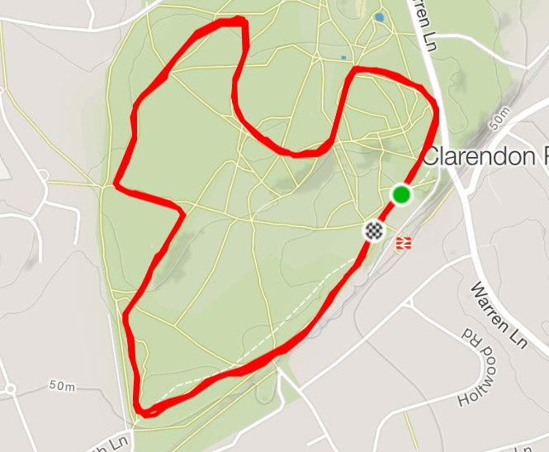
Time: Men 14:30, 12th January 2019
Parking: Oxshott National rail station KT22 0TA (free parking on Saturdays)
Toilets: Until 14:00 at Oxshott National rail station
Start: 1 minute walk from Oxshott National rail station Car Park (signed)
Course: The course starts on a wide grassy area but quickly narrows to a (three person width) bridleway. Fast runners are urged to establish an early lead in the first 75 meters. The course then meanders through a mixture of bridle ways, single track paths until you reach a sharp hill. There are several sharp bends. The course continues along wider paths until 100 meters to the end which narrows to a single path track until the wide start/finish area. The course will be marked using tape and flour.
Runners should be aware of roots, stones, trees and potential low branches along the route.
Men: Three laps (approx. 5.1 miles)
We do not have priority over other users of the woodlands, please respect their rights.
The course has been designed and marked by Elmbridge RRC. Elmbridge are hosting the event. The course will be marshalled by a mix of marshals from Elmbridge, Lingfield and Tri Surrey.
Questions or queries please contact:
Chris Davidson
(ElmbridgeRRC.menscaptain@hotmail.com)

