SPEEDBIRDS

LADIES 5km RUN
WEDNESDAY 3rd May 2017 7.00pm
British Airways Parklands at Harmondsworth Moor
Under UKA rules. UKA Permit 2016-23588 tbc

Course 5km, undulating, traffic free, single lap course

Location Accommodation Lane, Harmondsworth Moor, off the A4 Colnbrook Bypass,
Nr. Heathrow (postcode opposite car park UB7 0PD)

Prizes Individuals and Veterans plus a memento to every finisher

Facilities Toilets and parking (No changing facilities, please come ready to run)
Please note this course is not suitable for wheelchair users or pushchairs

Entries Entry fee in Advance £6.00*, On the Day £8.00*. Cheques payable to ‘British Airways Athletics Club’. * £2.00 discount on the above fees if you are a Registered Member of England Athletics, and supply your registration number.
Send entries to Steve Taylor, 188 Church Road, Hanwell, London W7 3BP
Closing date for postal entries: April 29th 2017.
Include a stamped addressed envelope 9” x 6” OR plan to collect your bib number at the start.

For more information please refer to: http://www.barunner.org.uk/Event_Ladies.shtml
Organised by British Airways Athletics Club, under UK Athletics rules

OFFICAL ENTRY FORM | For official use only | Cheque | Cash | £ Number |____|____|____|
Surname ............................................................ First Name ..........................................................
Date of Birth ............................................. Age on 3rd May 2017 ……………………………..
Address…………………………………………………………………………………………………………………………
Post Code ........................................ Telephone Number ........................................................
Results will be posted on our website and sent to all competitors who give their email address
E-MAIL ……………………………………………………………………………………………………………………..
England Athletics registration number (if you are an affiliated runner) ......................................…............................
Affiliated Athletic Club ……………………..…............................................................................…............................

I declare that: I agree to abide by the regulations governing the event and to obey the directions of police and marshals. I understand that I enter this race at my own risk and I will not hold the promoter or British Airways responsible for any loss or injury resulting from my participation. Furthermore, I will only compete if I am fit and well.

Signature.............................................................................. Date ..........................................

We record your details for race administration purposes only. They will not be passed to any third party. We would like to send you details of future races. Please tick if you do NOT want us to send you this information.

Directions to the car park and race start:
Harmondsworth Moor can be found just off the junction of the A4 with A3044 (Colnbrook Bypass) between junction 5 and 4a of M4.

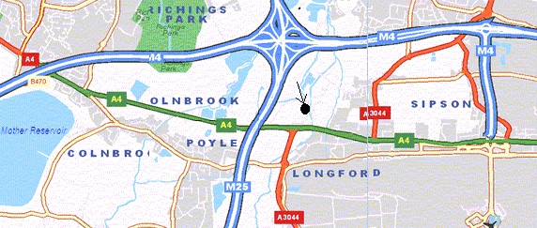

Follow Tarmac Way into Accommodation Lane to the car park. Race starts next to the car park.

