Runways newsletter of the Qantas Running Club Est. ~1970
  - March 2018
President: Vacant
Vice President: Vacant
Treasurer: John Gately
Secretary: Dave Taylor
Committee: Shane Batkin
Roger Moresi
Jason Vella
WARR Captain: Roger Moresi
Details for the QRC account are:
Qudos Bank
BSB 704 865\ Account: 02166990
Name: QAN
Description: please insert your name

 |  |  |  |  |  |  |  |  | 15
 |  |  | S | M | L | XL | XXXL | Total No | Cost | Paid
 |  |  | 3 | 1 | 1 | 1 | 1 | 7 | 105
 |  |  | 2 | 3 | 2 | 1 |  | 8 | 120
Roger Moresi and Rob G |  |  | 1 | 3 | 2 |  |  | 6 | 90
Stella Crisafi |  |  |  | 1 |  |  |  | 1 | 15
Jackson & Indiana Stan? | refer hatch |  | 2 |  |  |  |  | 2 | 30
Pamela Hatch (VIC) | plus, family |  | 4 | 1 | 2 |  |  | 7 | 105
Tim Garvey |  |  | 3 | 5 | 2 |  |  | 10 | 150
Shane Batkin |  |  | 3 | 3 | 4 |  |  | 10 | 150
Michael Stove, |  |  |  | 2 |  |  |  | 2 | 30
Glyn Sausman |  |  | 2 |  |  |  |  | 2 | 30
John Gately & Trish |  |  |  | 2 | 3 | 1 |  | 6 | 90
Mark and Lorelle Ward (QLD) |  |  |  | 4 |  |  |  | 4 | 60
Louisa White |  |  |  | 2 |  |  |  | 2 | 30
Shally Singh |  |  | 1 | 2 | 1 |  |  | 4 | 60
Michael Flower
Diana Morey |  |  | 1 |  |  |  |  | 1 | 15
Paul Demott |  |  | 2 | 4 | 2 | 2 |  | 10 | 150
Sandy & Rose Collinson |  |  |  | 1 | 1 |  |  | 2 | 30
Rosa Wallis (WA) |  |  |  | 1 |  |  |  | 1 | 15
Peter Ryan (Vic) |  |  |  | 6 | 1 |  |  | 7 | 105
Leigh Shane
Robert Taylor JQ | declined |  |  |  |  |  |  | 0 | 0
Greg Daffen VA |  |  |  |  | 6 | 4 |  | 10 | 150
Kevin Staines VA |  |  |  |  | 6 |  |  | 6 | 90
Brendan McNally VA
extras for sale by Team Cap |  |  | 4 | 3 | 3 | 2 |  | 12 | 180
Totals |  | 0 | 28 | 44 | 36 | 11 | 1 | 120 | 1800
A Recent Success
You might use a sidebar for a brief story about an important event or a company success story that you want to highlight.
This is also a wonderful place to show off your mission statement or other content you want to highlight boldly in every issue, such as upcoming events.
Dave Taylor our new Secretary
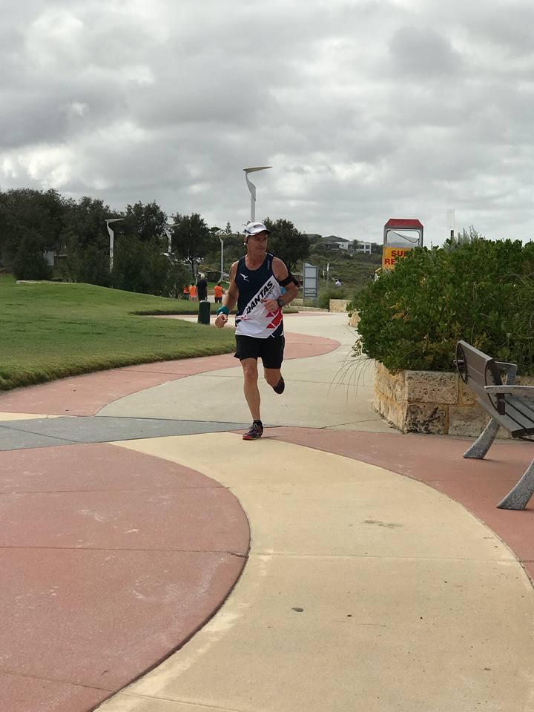
Michael Stove at recent Mt Penang Parkrun

in this issue
- Change to Newsletter
- AGM
- WARR Victoria update
- Heard around the track
- Parkrun Tourist news
- Roderick Hoffman (Legend)
- New members
- Next Club Run

looking for a new newsletter editor

Hi members - it is time for a change. We are looking for someone to take over the newsletter please. It is time for this editor to take a break. It produces itself with members sending in running stories We will now be producing a quarterly newsletter instead of a bi-monthly (facebook, yamma etc.)

AGM
The AGM was held at Dolls point on the 24th February with an excellent attendance. The following executive and other honorary positions were declared:
President: Vacant
Vice President: Vacant
Secretary: Dave Taylor
Treasurer & Public Officer: John Gately
Committee: Shane Batkin, Roger Moresi & Jason Vella
Warr Captain: Roger Moresi
Webmaster: John Gately with Jason Vella
Newsletter editor: Vacant with Neil Campbell filling in.
Merchandise Officer: Roger Moresi
Social Director: Susanne Burroughs
T shirt Committee: John and Susanne Burroughs, Roger Moresi

Key items fROm the AGM
- Increase in membership by 19 and club in sound financial position
- Susanne Burroughs thanked the retiring committee members and welcomed the new ones
- It was decided to raffle the $300 Travel voucher amongst financial members (refer later down)
- Approval to purchase additional Running Singlets in XS and S for members.
- Committee to discuss criteria for awarding life membership of the club.

Travel Credit Voucher to be WON!!!
The committee has been advised that the 2 FOC tickets the company provided in the past has been replaced by a yearly $300 worth of Travel credits.
The committee has decided to allocate the $300 credit as 2 by $150 vouchers and to select the recipients by allocating every financial club member one entry into a raffle draw.
Eligibility: You must be eligible for Staff travel benefits either you or your nominated travel partner.
You must be a current financial or life member of the club as at the date of the raffle.
The raffle will be drawn in the presence of at least 3 committee members on or after 29th April. The prize will be 2 travel credits worth $150 each.
No correspondence will be entered.

WARR Victoria 26-29th Sept 2018 Update
Don’t forget your ETA or ESTA
If you are travelling to Canada, you will require an electronic visa (eTA) and if you are transiting the USA on standby you better have an ESTA as well quote from the Westjet website
“Travel to Canada - Electronic Travel Authorization (eTA) Canada has introduced a new entry requirement, known as an Electronic Travel Authorization (eTA). If you are a foreign traveller and you do not require a visa to travel to Canada, you're expected to apply online for an eTA before travelling to Canada by air; exceptions include U.S. citizens and travellers with a valid Canadian visa. Canadian citizens, including dual citizens, and Canadian permanent residents cannot apply for an eTA.

The application process is affordable, doesn’t take long to complete, and in most cases the eTA will be granted within minutes of applying. To apply and find out more, visit Canada.ca/eTA.

Warr T-shirt Ideas wanted
Calling for ideas on the design for the T shirt for WARR in Victoria, Canada, BC
Please email John Burroughs at jasburroughs@optusnet.com.au

Heard around the Track:
Dave Taylor our new secretary is a Parkrun tourist and has just overtaken the Editor as the member with the most different parkruns. Keep an eye on the FB page relating to QRC parkrunners and join Dave when you see him parkrunning in your location.
It gets better, Parkrun tourists aim to complete the alphabet of parkruns A-Z, not even the much-travelled Roderick Hoffman (read his story below) has achieved the letter X. Dave, not to be beaten has discovered Australia has one town beginning with the letter X. It is Xantippe in WA. (google it.) Unfortunately, is has a small population, so not to be outdone Dave has written to the nearby township of Dalwallina and asked the local Caravan park owners to start a park run in Xantippe. We would guarantee the whole town would be booked out most Friday nights as parkrunners from around Australia., and the world travel there to complete their alphabet challenge.
Another event coming up that Dave is involved in, is in his home town of Tamworth on April 1st (not an April fools day joke). On this cool autumn morning over 50 people will be testing their fitness and endurance by competing in the inaugural Tamworth Trail Blazer event held at Flagstaff mountain in East Tamworth. This event which is the dreamchild of Warren Ansell, a local physio and avid triathlete and UTA runner, consists of a 15km loop on the trails around Flagstaff mountain. It is not compulsory to run, in fact there are a few local entrants just happy to get up early for a stroll in the hills. On offer is 3 distances, 15km, 30km or for the truly game, 45km. Dave will be competing in the 30km event and would love some QANTAS Running Club members to join him, so if you’re keen, contact Dave for further information.

First time parkrunner

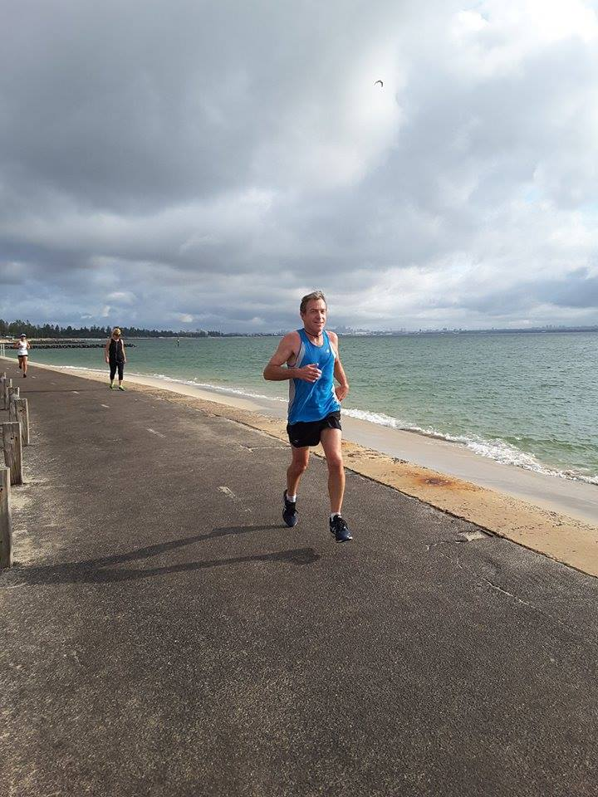

Parkrun Tourists
Many of our members know Roderick Hoffman, the British Airways Warr captain
He is a bit of a Parkrun tourist 222 different runs and still counting so we asked him to share his thoughts with us
. Being a parkrun tourist
16 February 2018
18:12
The ancient mariner is condemned to sail the seven seas never returning to a home port. As a parkrun uber-tourist, I sometimes think I've been given the same curse! I've never settled down at a home parkrun and I'm under constant pressure to get up earlier and earlier on a Saturday morning to travel to a new parkrun I've not yet run at.
I became an uber-tourist by accident, but since it didn't result in the death of an albatross I'm happy to tell more. After hosting WARR in London in 2010 I led an initiative within the BA Running Club to find ways to boost attendance at club events. We decided to stop ignoring the local parkruns that had become established whilst we had been planning WARR and instead join them - with a different club featured parkrun every other month. Although I didn't fancy getting up early on a Saturday morning to "only" run 5k as it was my initiative I had no choice. Our first club-featured parkrun was at Bedfont Lakes, near Heathrow airport, on 25th June 2011. Two months later we visited Bushy - a memorable run including being cheered on by a local jogger, one Mo Farrah. After that we ran at the delightful Black Park and then at the club popular venue Gunnersbury.

I wasn't hooked by these first four parkruns, run every other month, but then for Christmas I visited my Melbourne based sister and I realised that I could run the recently established parkrun around the Grand Prix circuit of Albert Park on New Year's Eve, literally on my way to the airport. The pattern of doing different parkruns was now established and I fitted in a couple of different London parkruns during January. My eighth parkrun was chosen by its name - that February was a very cold month and I chose the parkrun on the edge of London called "Gunpowder" as a venue to warm myself up at. I really appreciated the parkrun spirit that day - it was so cold that at the end of the first lap several runners paused in front of me…to put ON an extra layer for the second lap! But my pattern was now set, and I realised through Facebook and other parkrun media outlets that no one to date had set out to run fifty different parkruns with their first fifty parkruns. That then became my goal and I eventually made it up to 52 runs before I returned to Bedfont Lakes to claim my "50" parkrun shirt - in those days in the UK your achievement shirt could only be given to you at a home parkrun - so there I was to collect a shirt even though it was only my second visit there. I had chosen my 50th UK parkrun by its BA linked name, at the Sheffield parkrun called "Concord".

That was back in March 2013. I could then have adopted Bedfont Lakes as my home and "settled down" like normal parkrunners. But after a short period whilst I revisited some favourite parkruns, and others I'd recorded slow times at, I started visiting new parkruns again with new targets of 100 different parkruns, then 200 and now 250. At the time of writing this I've run at 222 different parkruns including in 14 different parkrun countries.
In the early days I was running a lone furrow but that is no longer the case. There is now a large community of uber-tourists and we regularly communicate in our own Facebook group, check our progress on the UK and International "Most Events" table and have occasional meet-ups at recently established parkruns. My 222 different events are only good enough for twentieth place on the most-events table! The leader has recently run his 400th different parkrun!
I'm often asked which are the best parkruns but I'm always cautious about answering the question because by saying that some parkruns are better than others implies that some are worse than others, but that is an unfair statement - just because a parkrun didn't ring my bell on the day I was there doesn't mean that it can't be the best parkrun in the world for those who live locally to it.

Below is a list of a number of parkruns that I think all uber-tourists should have on their "To Do" list:

- There is Bushy park in London - where it all started back in October 2004. Bushy regularly attracts 1,000plus runners so it is worth visiting even if only to see how smoothly the finish process works.
- Crissy Field (San Francisco) for the iconic parkrun photograph showing you approaching the finish line with the Golden Gate bridge in the background. Just pray that you are there on a day without the sea mist!
- Ashton Court near Bristol has a particularly challenging relief - it is an out-and-back route and the first 2.5k is uphill, then you turn around and see how quickly you can get back to the bottom. Much more fun than three laps round a flat field.
- But a flat run well worth doing is Portrush in Northern Ireland which is a parkrun run entirely on the beach. Each Saturday morning, they check the tide and then set the course anew. The sand is firm just above where the waves reach or if you prefer you can do the entire race barefoot through the waves.
- Bere Island (Ireland) - an adventure from start to finish - you fly to Cork in Ireland then get a lift or bus down to Castletown on the coast where a ferry takes you across to Bere Island. The fee you pay the ferryman also covers you for the minibus that takes you to the far side of the island and when the minibus gets to the parkrun they start the run briefing. Many Saturdays they will have more runners taking part in the parkrun than there are inhabitants on the Island. A new run has just started in Brassey in the Shetland Islands which promises to be a UK equivalent to Bere Island.
- Cieszyn (Poland) is unique because the start of the run is in Poland but after half a kilometre you cross over the river into the Czech Republic and continue the course in that country before returning into Poland for the finish - one parkrun but two countries, and you don't have to show your passport.
- There are some very scenic parkruns in the UK particularly those run on properties maintained by the National Trust. Penrhyn has a stunning castle that you run from, round and back into. Fountains Abbey, still on my to-do list, has a ruined abbey as its backdrop.
- Gunpowder - A unique feature of Gunpowder parkrun is that the start of the course is in the western hemisphere, but the finish is in the east - you cross the Greenwich Meridian several times during the run. The most northern and southern parkruns are also challenges to be undertaken through these are subject to change. The parkruns closest to the equator are East Coast Park and West Coast Park in Singapore.
- Zary in Poland is a popular destination for UK parkrun tourists because it is the nearest parkrun to the UK that begins with the letter "Z". parkrunners collect all the letters of the alphabet this way, other than "X" for which there is yet no parkrun in the world starting with "X". Some alphabet tourists compensate by running at Cross Flatts or at Exeter but as soon as a proper "X" parkrun starts up hundreds of UK parkrunners will be setting their travel plans.
- South Africa has some fantastic names for their parkruns - such as "Thousand Hills", "Cannibals Cave" and "Piggly Wiggly" and the world's biggest parkrun at North Beach where attendance has topped 2,500.

On the subject of South Africa, a number of us took in a parkrun the day before the World Airline Road Race in Stellenbosch back in 2013. This was the "Root 44" parkrun and proved to be somewhat more challenging than we would have liked it to have been just the day before serious races. In Dublin the BA team found flatter parkruns to do as our warmup the day before the 2014 WARR races and then last year, in Singapore, four of the team ran the East Coast Park parkrun which was at the same time as the WARR 5k, having already run the WARR 10k. This year, in Vancouver, we'll be doing the same with Clover Point parkrun running at the same time as the WARR 5k is scheduled to be. That's the problem with parkruns, once you get into them you just can't stop.

Roderick Hoffman (A160643)

The world's longest flight routes (by distance)
Perth London, Qantas will be 14,498 making it no 2 for while
- Doha-Auckland, Qatar Airways, 14,529km
- Dubai-Auckland, Emirates, 14,200km
- Los Angeles-Singapore, United Airlines, 14,114km
- Sydney-Houston, United Airlines, 13,850km
- Sydney-Dallas, Qantas, 13,804km
- San Francisco-Singapore, United Airlines & Singapore Airlines, 13,592km
- Atlanta-Johannesburg, Delta, 13,581km
- Abu Dhabi-Los Angeles, Etihad, 13,502km
- Dubai-Los Angeles, Emirates, 13,420km
- Jeddah-Los Angeles, Saudi, 13,409km
Read more: http://www.traveller.com.au/united-airlines-direct-flights-from-sydney-to-houston-take-off-h0jlui?promote_channel=edmail&mbnr=MTk2NzE3OA&eid=email:nnn-13omn645-ret_newsl-membereng:nnn-04%2F11%2F2013-smh_travel-dom-travel-nnn-smh-u&campaign_code=13ITR004&list_name=10078_traveller_news&instance=2018-01-19--01-09--UTC#ixzz54asMCanf
Follow us: @Traveller AU on Twitter | Traveller AU on Facebook

WARR discounts
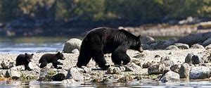
Check out discounts for flights on the WARR website
=====================================================================================

Fees for 2018 now due for those not on payroll deduction
Make sure your membership is up to date to be in the running for the Travel voucher raffle

Next club run
April 29th Oatley Park run 2 and 5km. entries available here https://www.oatleyparkfunrun.com/

Save the date
June 18th Caloundra Foreshore run
We now have doubled the QLD club members with Sandy and Rose moving to the Gold Coast and Anne and Neil moving to the Sunshine coast, joining Mark and Lorelle Ward. Not to forget Zac Rule, Dave Humphreys in Brisbane and Greg Bingham on the Downs (apologies if I missed anyone)

Classic Merchandise run out sale is still on, please contact Roger Moresi

Please Contact Roger Moresi for the innovative Design Club running singlet at rogedoge007@hotmail.com

Contact Us
Qantas Running Club
John.gately@qantas.com.au

News items to the editor
Nortona@outlook.com

Web address: www.qantasrunningclub.org
Facebook:

