I’ve always wanted to complete the Capital Ring in one go and this was my 3rd attempt. I’ve run on sections of this 78 mile round London route many times over the years. I did about 25 miles of it when the Ealing Eagles tackled the whole route as a relay in 2014 with one or two of us running sections of 7 to 10 miles. We were a bit short of runners so I ended up running 3 sections over the day – we finished in 14:08:53.
In 2017 I split it into 3 chunks of roughly 26 miles and did it over 3 days as part of my preparations for the Marathon des Sables. It gave me an idea about what I was letting myself in for in terms of many marathons on consecutive days but not really much prep for the weather as it was mid-January - cold and wet!
I ran the 30-mile London Ultra a couple of times about 10 years ago. It was over a route that used the Capital Ring from near Streatham Common to finish at the Perivale Athletics track in Ealing quite close to where I live.
This time, as with my two previous solo attempts, I was going to start from Osterley Lock in Elthorne Park, Ealing and proceed in a clockwise direction. Unlike the previous attempts I’d be walking as I am trying to clear up an injury and have avoided running for about the last eight weeks. At best I thought I might finish in close to 24 hours.
After getting up at 4am, I’d planned to leave from my house in South Ealing at about 4:30 but didn’t get away until about 4:50 arriving at Osterley Lock a little after 5 by which time the sun had fully risen.
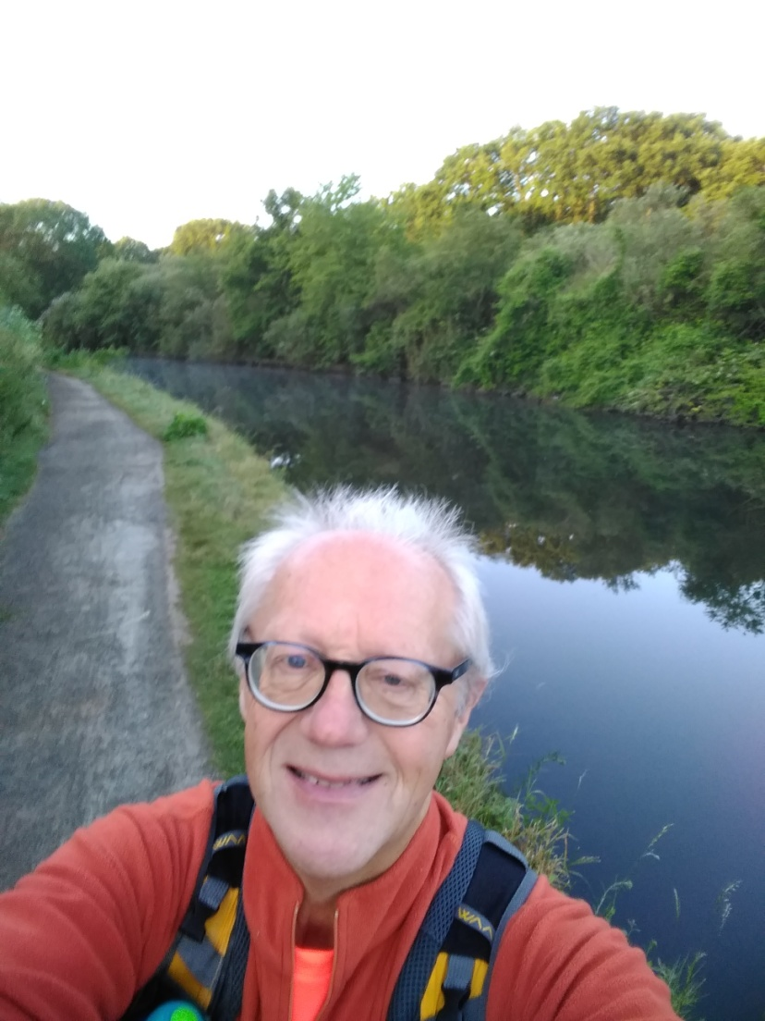
The first few miles of the route is on a stretch of the River Brent/Grand Union Canal that starts from the Thames in Brentford with the route following the river into Brent Valley Park just after the Fox pub in Hanwell.
I’d walked this section a few days previously, doing BA’s I-Spy challenge and unlike last time I saw a heron and then a little later two magpies!
After Brent Valley Park the route went into Perivale Park where I came across this unusual park bench:
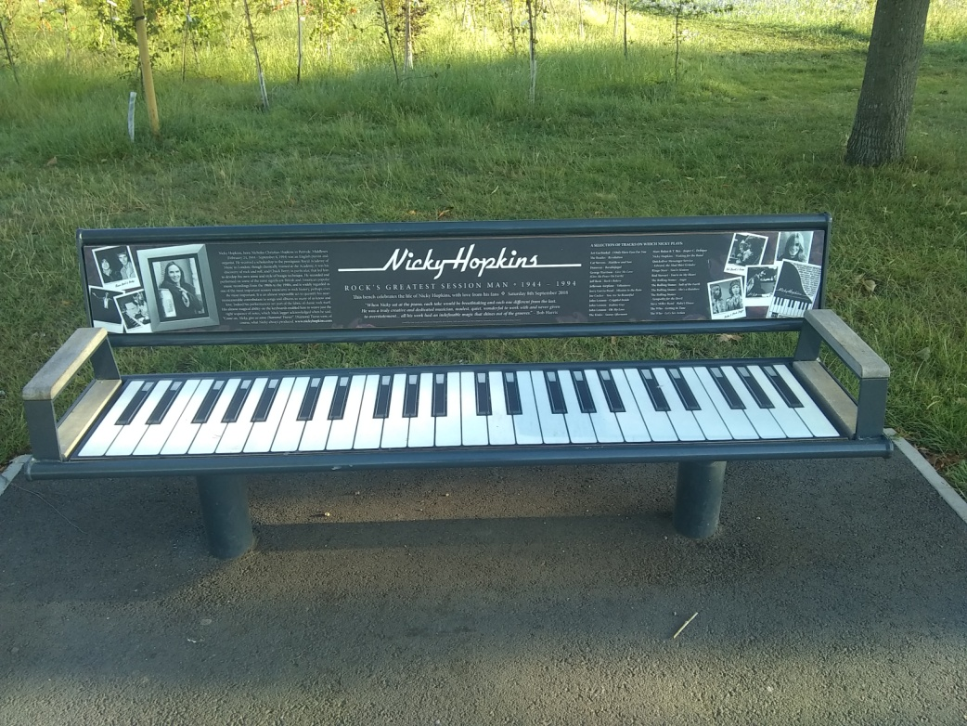
Next I rejoined the Paddington branch of the Grand Union Canal and followed it for about a mile to Horsenden Hill. I had been think of saving my legs and taking a shortcut here to avoid the hike to the top of the hill but as it was such a bright sunny day I though the views might be worth the trip – and they were could pick out many of the capital’s tall building including The Shard.
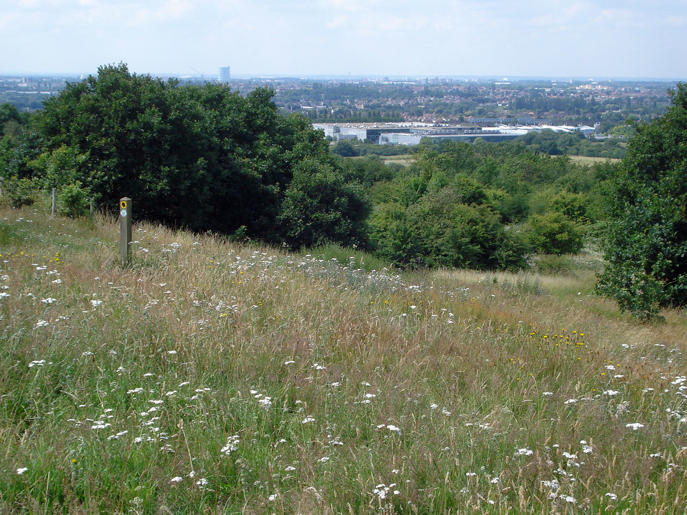
After passing through Sudbury there was another climb up to the centre of Harrow-on-the-Hill which, at 375 feet, is one of the highest points on this generally flat route. The descent from the hill was via Football Lane and then across the playing fields of Harrow School to Northwick Park Hospital.
The next couple of miles were mainly on the suburban streets of Kenton and Preston before another climb up Barn Hill into Fryent Country Park.
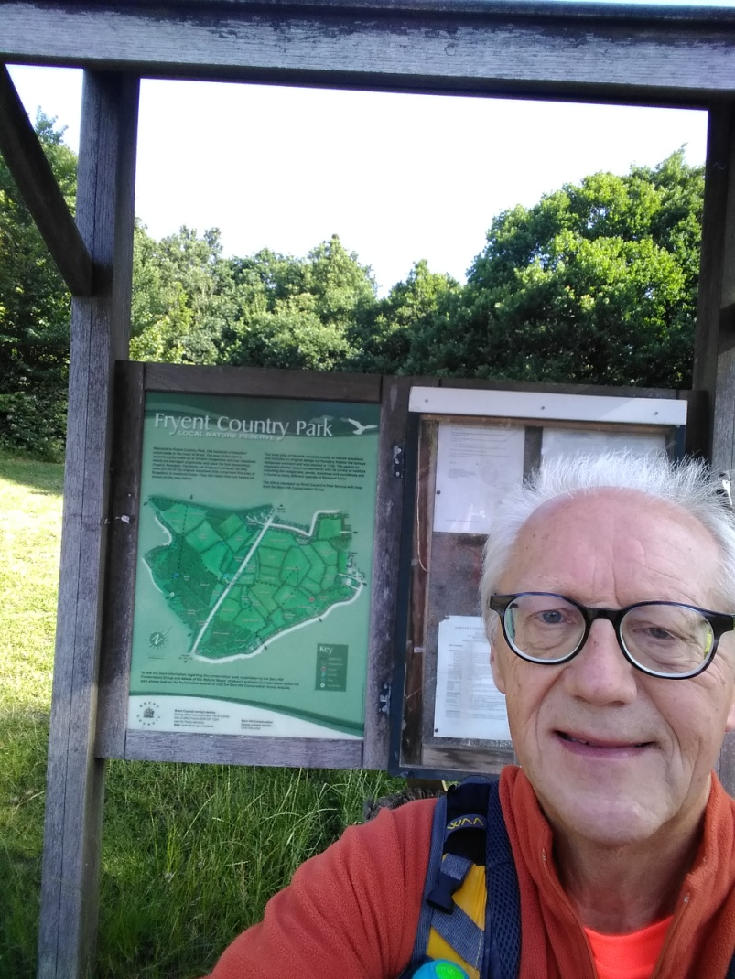
After leaving the park I followed some Capital Ring route markers down into Wembley near the stadium and Wembley Park Station. This was my first bad mistake of the day – the route markers I had followed were for one of the many 'link' routes to/from stations etc to help people using public transport get on and off the main route. The detour and time lost planning the best route back to the Capital Ring proper cost me about 25 minutes in time.
Brent Reservoir (aka the Welsh Harp) was next and by this time things were beginning to get very warm with bright sunshine and a Mediterranean blue sky. After leaving the water it was into Hendon, across the North Circular into East Finchley and on to Highgate. I then joined an old railway for a couple of miles where the route would exit into Finsbury Park. However, the gate I needed to use to enter the park is quite narrow and had been closed for COVID-19 social distancing reasons.
I’d now been walking for just over 8 hours and had covered 25 miles – a little behind my planned schedule of 26 mainly due to my problems in Wembley.
On the detour I lost the Capital Ring way marks:
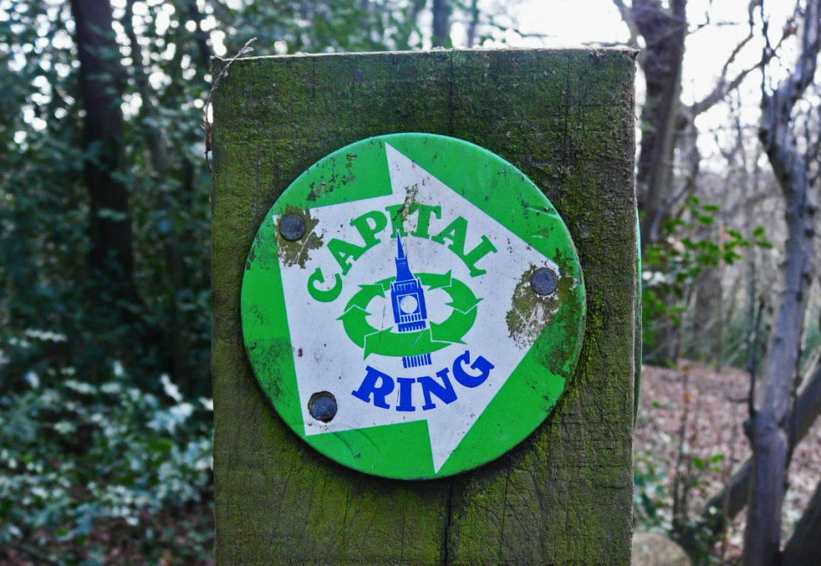
...and only picked them up again as I approached Stoke Newington. From there I followed them to the River Lea Navigation and headed south to the Olympic Park.
Once there I turned east on The Greenway footpath which overlooks the Olympic Stadium and the helter-skelter thingy. The Greenway is not as green as it sounds – it is built on top of the Joseph Bazalgette Northern Outfall Sewer! It smelt a bit – especially with it being such a hot day.
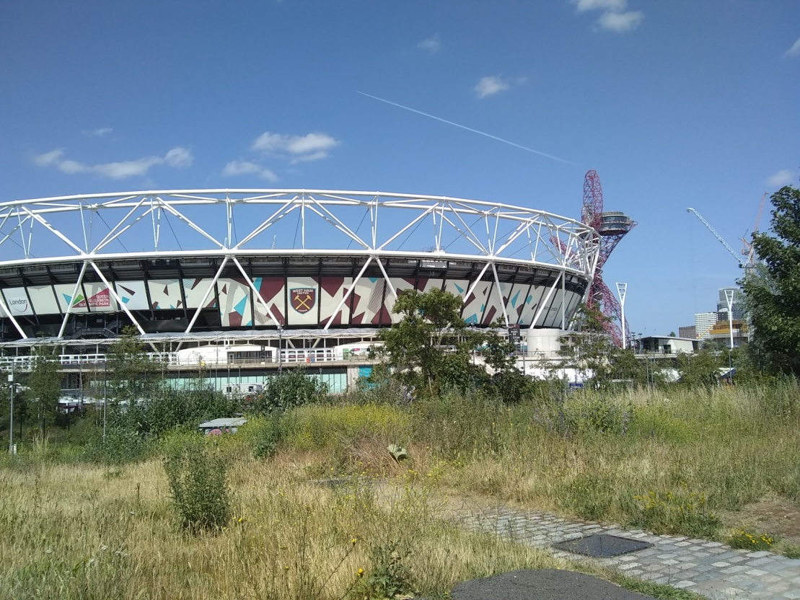
Still on the Greenway I passed through Stratford, West Ham and Plaistow before leaving it just after Newham University Hospital.
Next up was Beckton District and then New Beckton Park which brought me to the Cyprus station on the DLR.
The path then took me through the grounds of the University of East London to overlook Gallions Point Marina and across the water to the runway of London City Airport. I thought the airport had been closed due to COVID-19 but surprisingly I saw a plane take off.
I rounded the end of the Marina and completed the final mile to the northern end of the Woolwich Tunnel where I used the lift to save my now very weary legs.
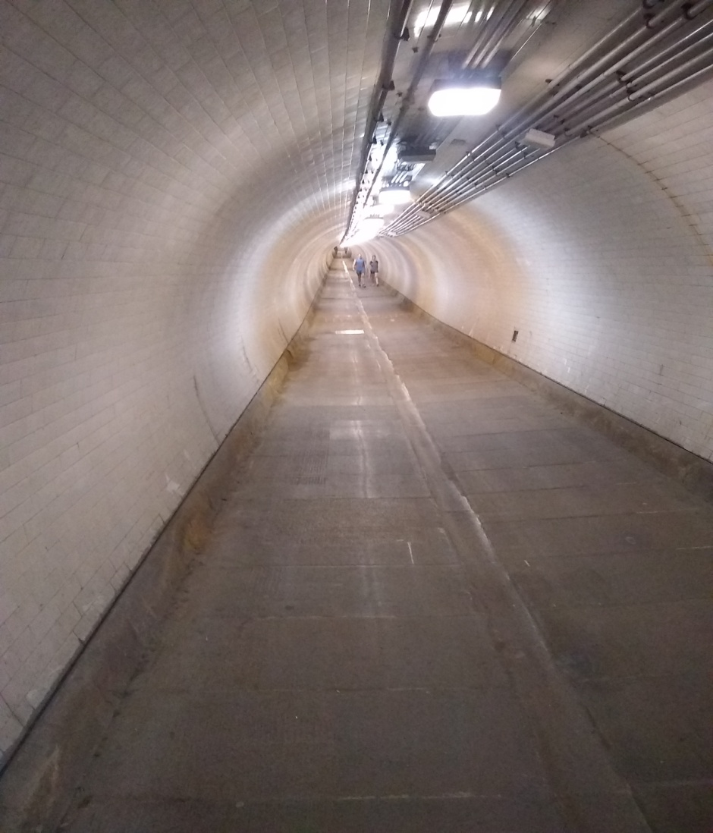
The official guidebook for the Capital Ring starts from the southern end of the tunnel but for my chosen starting point, Osterley Lock, this is about the half-way point. About 39 miles down covered in 12 hours and 50 minutes – 50 minutes slower than I would have liked.
Things started going pear-shaped soon after I left the exit from the tunnel and I struggled to find Capital Ring way markers after finding the path leading from the tunnel shut for major construction works.
Eventually found myself back on the Capital Ring when I got into Maryon Park. From here, another way-marked path, the Green Chain Walk, follows the same route for the next 16 miles to Crystal Palace. In theory this should have made staying on course easier as there would be way marks for both paths – in practice this wasn’t the case for me as I got lost time and again.
I fumbled my way through Charlton and Hornfair parks to then reach and cross Woolwich Common sometimes seeing way marks only to lose them again. Got to Eltham Common and tried heading across it towards Falconwood – got so lost I had no idea where I was. Tried using Google Maps Go on my mobile to get back on track but couldn’t match where I was with the maps in the guidebook. My mobile battery was also running very low so decided to keep it for emergency phone calls only.
I had a hospital appointment in the morning and did not want to miss it so decided to get a bus and skip some of the course to get back on schedule. I was on the bus for about 40 minutes covering about 8 miles and got off outside one of the entrances to Crystal Palace Park.
Couldn’t see where I was in relation to the Capital Ring and set off towards Streatham – got lucky and found the route again as I entered Westow Park but lost it again when I came out the other side.
It was now dark and getting difficult to read road names etc. Found I had been going completely the wrong way for half a mile and then with the half mile back and now moving rather slowly had lost another 25 minutes! Rather dispirited I decided to get another bus which took me to Clapham Common where I stopped off at Five Guys to get a takeaway of burger and chips! Just what I needed.
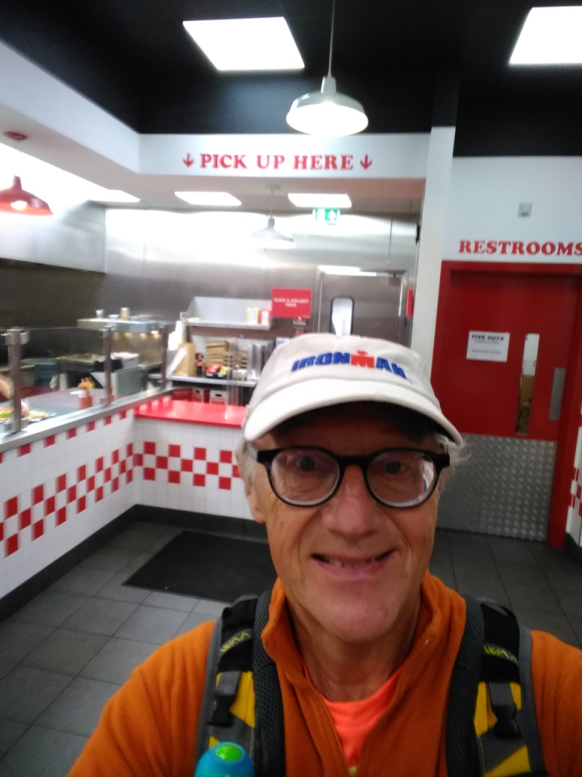
Decided just to get home by the most direct route and not risk getting lost again and so decided to follow the South Circular to Kew Bridge via Wandsworth, Putney, Mortlake and North Sheen. Ten miles and 3 ½ hours later I’d crossed Kew Bridge and was in Brentford. As I turned off Brentford High Street towards South Ealing it had just turned to 3am and I got home about half an hour later. It had been a long day. I will have another go next June.

