Ladies League Fixture 4 Richmond Park Feb 13th 2016
Hosted by Ranelagh Harriers
PLEASE NOTE EARLIER START TIME FOR ALL RACES
Senior Women: 11:30am
U15/U17: 12:30pm
U13: 1:00pm

There is a wedding in Pembroke Lodge on this day, please be considerate and take public transport to the park if possible. If driving consider using alternative car parks and jogging over to the start at Sidmouth wood.
If using Pembroke Lodge car park please arrive early as it will be extremely busy

There are no changing or shower facilities, please arrive at the venue changed.

Ranelagh Clubhouse

Start/Finish

Parking

Toilets (free) Petersham Gate, Pembroke Lodge, Roehampton Gate

Toilets (20p) Richmond Gate, Sheen Gate, Robin Hood Gate, Kingston Gate, Ham Gate

Toilets (seasonal) Isabella Plantation

Scale each small square is 500m x 500m, each large square is 1km x 1km

0 base point near to Start and Richmond Gate
1, 2, 3 distance in km from base point

Vehicle Entrances

Richmond Gate
Sheen Gate
Roehampton Gate
Kingston Gate
Ham Gate

Visitor Information
https://www.royalparks.org.uk/parks/richmond-park/visitor-information/opening-times-and-getting-here

Team Managers
Please aim to complete your declarations in advance of the race to make processing of results easier.
Results will be available on http://www.surreyleague.org/ as soon as possible after the race.

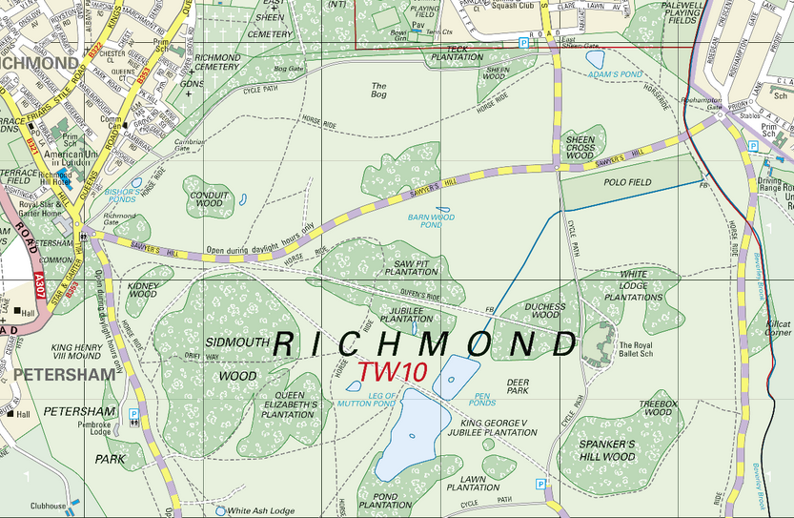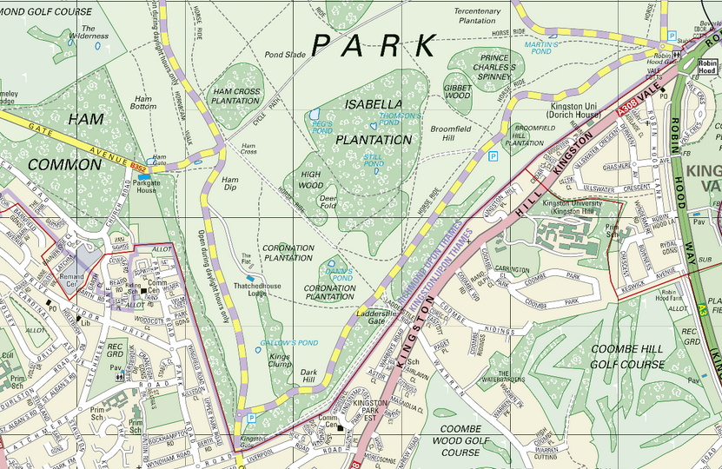
3
2
1
1
3
2
1
0

Course Map:
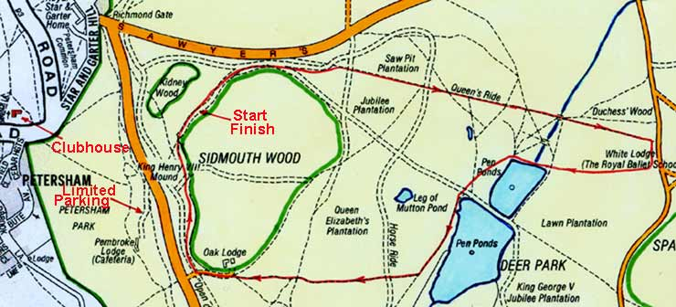
A
E
B
C
J
G
D
F
I
H
K

Senior Women: 11:30am One short lap + one full lap Start-A-B-C-E-F-G-H-I-J-K Start-A-B-C-D-E-F-G-H-I-J-K-Finish 5.03 miles / 8.10 km

U15/U17: 12:30pm One full lap Start-A-B-C-D-E-F-G-H-I-J-K-Finish 2.84 miles / 4.57 km

U13: 1:00pm One short lap Start-A-B-C-E-F-G-H-I-J-K-Finish 2.04 miles / 3.28 km

