BRITISH AIRWAYS CLUBS "CONCORDE" Open 5 Mile Sunday 17th June 2018
Licence no 2018-35072
Please read these notes carefully and study the runners map provided.

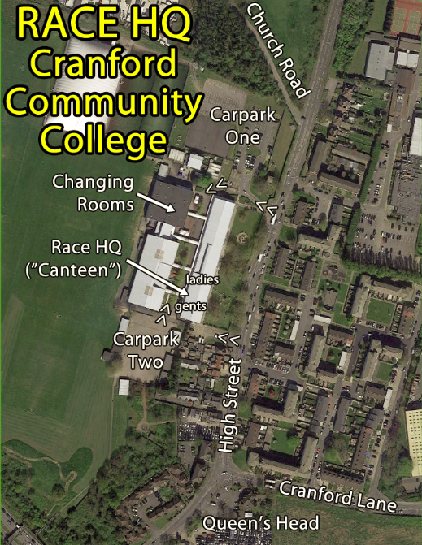
Race HQ is at Cranford Community College, High Street, Cranford, Hounslow, Middx., TW5 9PD

Please check that your details on the list of participants posted at the Race HQ are correct as they will be used for determining age group and team prizes. Please notify any discrepancies to the Entries Co-ordinator at the pavilion before the start.

Event Schedule:
- Race HQ and carpark opens 09:10
- Leave Race HQ to get to start for fun run 09:50 (latest),
- Fun run start 10:15,
- Leave Race HQ to get to 5 Mile start 10:40 (latest),
- 5 Mile race briefing (at start) 10:50,
- Race start 5 Mile 11:00,
- First 5 Mile finisher: from 11:25,
- Prize giving: 12:30 in the Race HQ.

Car parking for competitors and spectators:
Please use the car park at the Race HQ. There are carparks at both the northern and southern ends of the building and either or both could be in operation depending on other events underway. The sourthern end car park is via the “Deliveries Only” entrance. The car park at St Dunstan's church is for race officials and churchgoers only. Church Road is not suitable for leaving parked cars. No dogs at Cranford Community College please (other than from the carpark to the street).

Arrival:
Please plan your journey so as to arrive at the Race HQ by 10:30 at the latest for the 5 Mile and 09:45 for the Fun Run, so that preparation can be completed in time and you have time to get to the start.

The start is about half a mile from the Race HQ. Allow time for your warm-up jog to the start which is reached via Church Road.

Tracksuits etc. may be handed in at the start and will be transferred to the finish area and kept under cover during the race. Please bring a labelled bag and note that we cannot take responsibility for anything lost.

Competitor numbers:
Some competitor numbers will be posted out prior to the event, others will be made available at Race HQ prior to the start. The number must be worn on the front of your vest/T-shirt, attached at all four corners throughout the race. Pins will be available from the Entries Co-ordinator. In case of a situation arising please write on the back of your running number emergency contact details for a friend or relative and please also write details of any medical condition, allergies or medication used that someone treating you needs to know about. Alternately wear a wristband with ICE information on it.

Changing, showers and toilets:
There are changing rooms at the Race HQ with showers. Please do not leave any belongings in the changing rooms during the race. There are toilets at the Race HQ.

Refreshments:
Water will be available at the half-way point, and water/squash at the finish.

Medical Cover:
St John Ambulance personnel will be covering the race. Should you need assistance, speak to one of the marshals, who will help you to locate them.

Course Suitability:
The course is not suitable for wheelchairs, pushchairs or by runners with dogs. For those with disabilities please advise us before the day of the event if you would anticipate needing assistance on the route or before/after the event.

Runners on the course:
The course includes metalled roads, paths and cycle tracks and some pavement. With the exception of the start in Church Road the roads will not be closed to traffic. Runners should keep to the pavement or to the left hand side of the road except where directed by marshals or the police. Along the A4 & A312 runners must keep to the footpath/cycle path or be liable to disqualification.

Headphones are not allowed in this event:
The course features significant stretches on or alongside roads that are not closed to traffic. This event is staged under the UK Athletics Rules for Competition and this includes the necessary 3rd party insurance. The UK Athletics Rules state that headphones must not be worn in events with courses that include running on road carriageways that are not completely closed to traffic. The concern is that headphones may prevent runners from hearing approaching traffic and/or marshals instructions. For this reason we have to forbid the use of headphones and other earpieces and we are prepared to disqualify anyone who has them (and we have done in previous years). If you have a medical reason for needing to run with earpieces please advise us before the start.

Lead Cyclist:
A race marshal will cycle ahead of the leading runner.

Distance and distance markers:
The course has been accurately measured (certificate SEAA 13/097) and is a full 5 miles. Each mile will be marked. Over the final km, because the finish line is hidden from view, there will be 500m and 200m “to go” signs to mark the approach.

Finish Procedure:
Please make sure your number is clearly displayed as you cross the finish line and that your number has been recorded at the end of the funnel. All finishers will receive a commemorative “Concorde” horse-brass. Water/squash will be available at the finish. After finishing please keep clear of the course and allow slower runners to have a clear run to the line.

Retirements:
If you are forced to withdraw from the event before reaching the finish please inform a Marshall wearing an orange or yellow waistcoat. Transport will be arranged if necessary.
The last runner on the course will be followed by a race official on a bicycle wearing an orange or yellow waistcoat.

Time Limit:
There is a time limit of 75 minutes. If any competitor seriously doubts his/her ability to complete the course within 60 minutes they are asked to contact Roderick Hoffman on roderick@rhoff.org.uk before Thursday 14th June to discuss the possibility of an early starting time. To try to ensure that the prize giving can start on time (at 12:30 noon) the official timekeepers will be withdrawn at 12:15.

Back at the Race HQ:
While the results are being analysed, hot drinks should be available.

Prizes:
The Concorde Five Mile Road Race has a £540 prize fund with prizes for:
- The first three male finishers, first two male veterans in the Vet 40 category, first two MV50, first MV60,
- The first three ladies finishers, first two ladies veterans in the Vet 35 category, first two FV45, first FV55,
- Two additional prizes to be decided, immediately prior to the race, depending on entrants,
- UKA Affiliated Team Prizes (first three to a team for men and ladies, based on combined time),
- LBH Medals may be awarded to London Business House teams, according to rules.
- The leading British Airways Athletics Club lady and man will hold the George Lambert Trophy jointly for a year.
NB: If a runner in a Vet category finishes in the top three overall then they are awarded the relevant top three prize and any potential Vet category prize goes to the next finisher within that Vet category. Cash prizes awarded will be in running vouchers.

Team Competition: The team results are based on the fastest three competitors per team and their lowest combined time. Competitors need to state the team for which they are competing on their entry forms or in writing before the start of the race. Competitors may compete for their first or second claim clubs. First prize will be awarded to the lowest scoring team from those clubs affiliated with UK Athletics. Credit will also be given to two other finishing teams which may include non-affiliated clubs or teams.
The event is also a London Business House event and additional team prizes may be presented to the top performing teams.

Adopted Charities: The British Heart Foundation will receive a minimum donation of £1 per Concorde Five entry and a donation will be made to St John Ambulance in thanks for their services.

Results:
The results will be sent to all competitors who supplied a (legible) e-mail address on their entry form. Paper copies will be sent to any competitor depositing a stamped self-addressed envelope (9" x 6") with the Entries Co-ordinator before the start or at the prize giving. Alternatively, the results will be published on our web-site http://barunner.org.uk/Event_Concorde.shtml a day or so after the race.

Public Transport – see www.tfl.gov.uk for more information:

Travelling by Bus:
There are 3 buses which travel close to the Race HQ. The 105 and H28 stop just short in ‘High Street’ (Opposite Cranford Community School). The 111 stops in ‘Cranford Lane’ with the closest stop being near to the Queen’s Head Public House. There is a short 2 or 3 minute walk, from either of these stops to the Race HQ. Bus E6 stops in Carfax Road 0.5km from the start although this is via a short cut subway under the M4 which is not signposted on the event map.

Travelling by Train:
The nearest train stations are Southall or Hayes&Harlington. From Southall station, take the 105 towards Heathrow. From Hayes&Harlington there are various bus options, including E6 to Bull’s Bridge Tesco and then H28 to High Street or 195 bus (towards Ealing Hospital) to Southall/Brent Road and then a 105 (towards Heathrow). In all cases, see the directions for ‘Travelling by Bus’.

Travelling by Tube:
The easiest tube station is Hounslow East. From here you will need to catch a 111 bus to High Street Cranford. See ‘Travelling by Bus’.

Post Race Refreshments:
We recommend the Queen’s Head, Cranford (website: http://www.queens-head-cranford.co.uk/). For Sunday Lunch “we offer a selection of two roasts served with all the trimmings plus a selection of Sunday Specials”. Tables can be reserved via email: mailto:thequeensheadcr@gmail.com .

