SURREY LADIES XC LEAGUE DIV 1 & 2
SATURDAY 3RD DECEMBER 2016
TIMETABLE
12:00pm – Senior Women (approx 6km)
1:00pm – U15 & U17 Girls (approx 4km)
1:30pm – U13 Girls (approx 3km)
Clapham Chasers welcome you to this event which will be held on Mitcham Common. Race Headquaters are located at the MillHouse Ecology Centre Windmill Road, Mitcham CR4 1HT. Please read the following information carefully and distribute to runners and officals who will be attending.
DIRECTIONS: The Eco centre is located on Windmill Road, off the A236 (Croydon Road). THERE IS A CAR PARK AT THE ECO CENTRE BUT THE NUMBER OF SPACES IS EXTREMLEY LIMITED. Please do not use the Harvester Pub Car Park next to the Eco Centre. There is also no street parking near the start.
PUBLIC TRANSPORT: PLEASE USE PUBLIC TRANSPORT WHERE POSSIBLE.
By Rail/Tram
The nearest station is Mitcham Junction. Mitcham Eastfields is also a short walk away. Trains leave Clapham Junction every half an hour for both Mitcham Junction and Mitcham Eastfields. The nearest tram stop is Beddington Lane. If walking from Mitcham Junction there is a footpath inside the Common running parallel to Croydon Road. Once you arrive at the junction of Carshalton Rd and Croydon Rd, the footpath to Windmill Road is clearly signposted. Also be aware the walk from Beddington Lane Tram Stop is on a very narrow path next to a busy road.

By Bus
The 264 (Croydon to Tooting), 118 (Brixton to Morden), 127 (Purley to Tooting), and the S1 (Banstead to Mitcham) all stop within walking distance to the Common.
FIRST AID: Qualified first aiders will be in attendance should medical assistance be required. If hospital treatment is required, the nearest Accident and Emergency department is St George’s Hospital Tooting.
FACILITIES: Race HQ is at the Millhouse Ecology Centre Windmill Road. There are limited toilets at the Eco Centre but no changing facilities so you are therefore advised to come ready to race. If using the toilets please ensure they are left in reasonable state. Mitcham Common is a public space so all runners and spectators are asked to respect the rights of other users. Competitors are responsible for their own safety, before during and after the competition.
COURSE: Mitcham Common provides a wide variety of undulating terrain and underfoot conditions.
Depending on the weather prior to the event, there may be some deep mud. The wearing of spikes is advised but please be aware that there are sections of stoney paths. Courses will be fully marshalled on the day with marshals wearing yellow bibs. See course map below:

DECLARTIONS AND RESULTS: Please ensure that declaration sheets are handed in good time before the start of each race. Results will be available on surreyleague.org as soon as possible after the race.

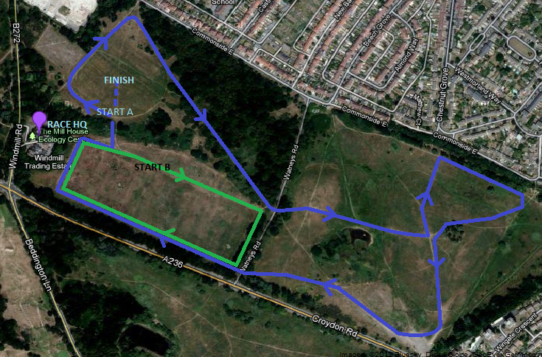

12:00pm Senior Ladies, 2 x large laps (approx 6km)
1:00pm U15/17 Girls, 1 x large lap, 1 x small lap (approx 4km)
1:30pm U13 Girls, 1 x large lap (approx 3km)

All 3 races will start at START A marked on the above map.

