Surrey League match 4 - saturday 7 february 2015
on Farthing Downs start at noon

The final Surrey League match will be held at Farthing Down Coulsdon.

The SW start is at noon. 8km two large laps ABCDEBFA X 2
The u15/u17 start is 1pm 4km one large lap ABCDEBFA
The u13 start at 1.30pm 3km one small lap [to tea rooms] ABCBFA
A= start & finish

Teams:-
Five to score in SW race
Four in the girls races.

Start:-
It is the usual SLH start at Farthing Downs.
On the Downs between Downs Road and Ditches Lane about 100m from the bottom gate.
http://www.streetmap.co.uk/newprint.srf?x=529922&y=158573&z=1&sv=529922,158573&st=4&ar=Y

Race HQ South London clubhouse. 194 Brighton Road CR5 2NF
http://www.southlondonharriers.org/about-us/where-we-are.html

Course:- 8km over two laps of 4km approx.
Course map below

The course is mainly on grass footpaths, which can be muddy. Over the section through the woods there are roots and flints to be aware of on this downhill path. The ascent out of the Valley is over a chalky path which can be slippery. The course crosses Ditches Lane twice, which is manned to stop traffic.

The course route goes south from the start up the hill. It follows the path on a right-hand camber, crossing the road just before the second cattle grid near the car park, then S-SE to the edge of the woods. It cuts down from the “tea-rooms” S-SE on a stony path through Devilsden Woods, baring left at the fork halfway down. As the path emerges from the woods, the route turns sharp left down a grassy slope, and left again at the bottom of the valley onto a path.
After 400m the route turns left off the path to ascend a gully, up through the trees to the gate, and along grassy paths on a right hand camber to the right side of Ditches Lane, until crossing the road 100m before the finish of the lap.
Second lap is a repeat of the first.

Note:- Tents are not allowed to be pitched on Farthing Down.

Transport
Parking: There is parking, some 400m from start, near the Tea rooms on the Downs at the summit of Ditches Lane or the usual public car park at Lion Green Road. Towards the back it is long term parking which is cheaper.

Public Transport
The nearest station is Coulsdon South with four trains and hour from London Bridge and East Croydon. Ten mins walk to start, right form station down the steps and right into Marlpit Lane then right up Ditches lane or for clubhouse follow Brighton road to right into Coulsdon.

The nearest A&E hospital is either East Surrey Hospital in Earlswood [Redhill] RH1 5RH or St Helier Hospital Wrythe Lane Carshalton, Surrey SM5 1AA
There are changing facilities at our clubhouse where there will also be refreshments after the race.

Have a good run.

See you on sat 7 feb
Jake Clausen
South London

Womens Surrey League Div. I . 7th. february 2015
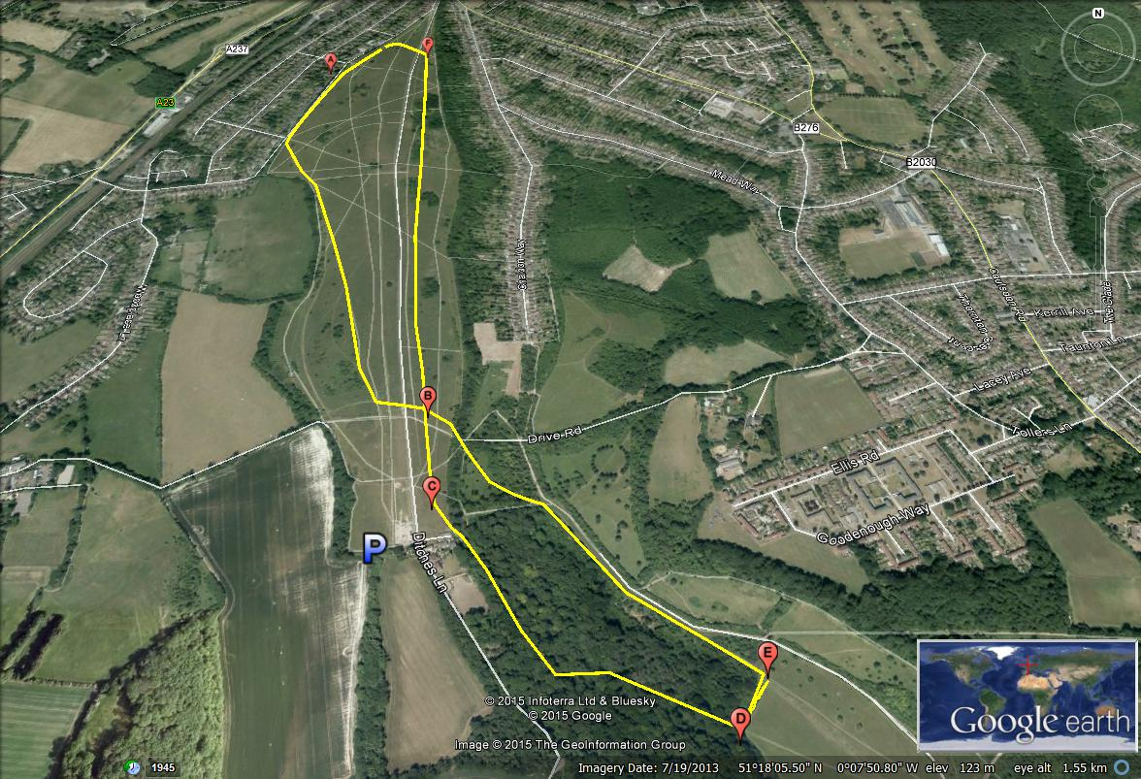

Women: 2 laps: ABCDEBFA X 2
Under 13: 1 lap: ABCBFA
Under 15/17: 1 lap: ABCDEBFA

