2XU Surrey Men’s Cross Country Race 8th February 2014
Start time : Boys/U17s : 14:30
Men : 15:00
Venue : Newlands Corner, Guildford, GU4 8SE
The start of the race is located approximately 400m for the Newlands Corner Car Park. Please see the map below :
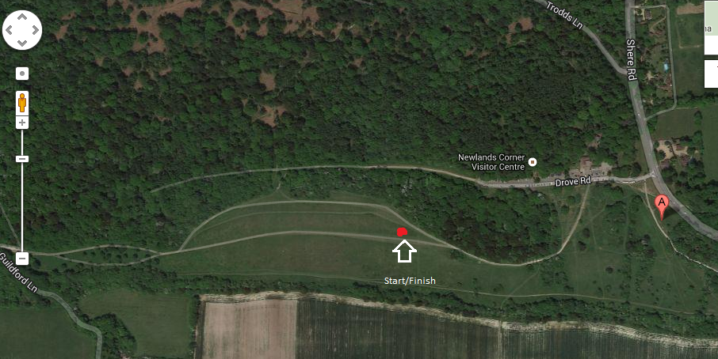
Parking :
Parking is limited at Newlands Corner, so please car share wherever possible. As part of our agreement with Surrey Wildlife Trust we are asking for a donation of £1 per car (25p each if you car share!) to go directly to Surrey Wildlife Trust to contribute to the upkeep of the car park. There is alternative parking at the Merrow Park and Ride site at the bottom of the hill although this is quite a walk!
Course :
The course is undulating and roughly 3.9 km per lap. The junior race will complete one lap and the senior two laps. The map below is a gps track of the course. For the men, they will start the second lap at point A by bearing slight left and upwards towards the woods.
